EXP NO 1: CREATE A SIMPLE CLOUD SOFTWARE APPLICATION AND PROVIDE IT AS A SERVICE USING ANY CLOUD SERVICE PROVIDER TO DEMONSTRATE SOFTWARE AS A SERVICE (SAAS).
DATE:
AIM:
To create a simple cloud software application and provide it as a service using any cloud service provider to demonstrate software as a service (saas).

PROCEDURE:

STEP1: GOTO ZOHO.COM
STEP 2: LOGIN TO THE ZOHO.COM
STEP 3: SELECT ONE APPLICATION
STEP 4: ENTER APPLICATION NAME
STEP 5: CREATED NEW APPLICATION
STEP 6: SELECT ONE FORM
STEP 7: THE SOFTWARE HASE BEEN CREATED.

IMPLEMENTATION:
STEP1: GOTO ZOHO.COM

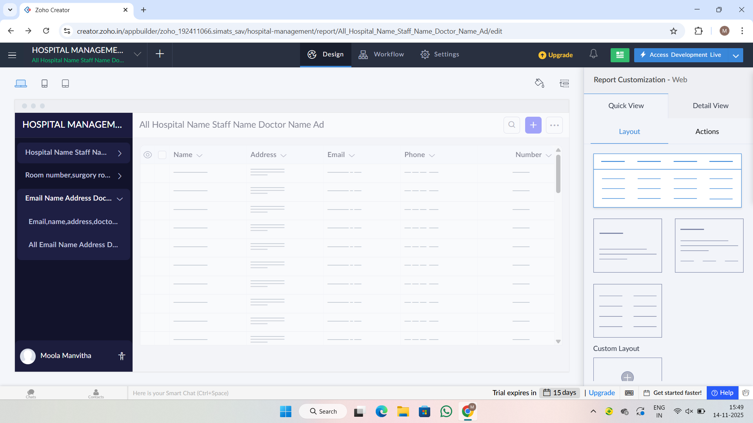
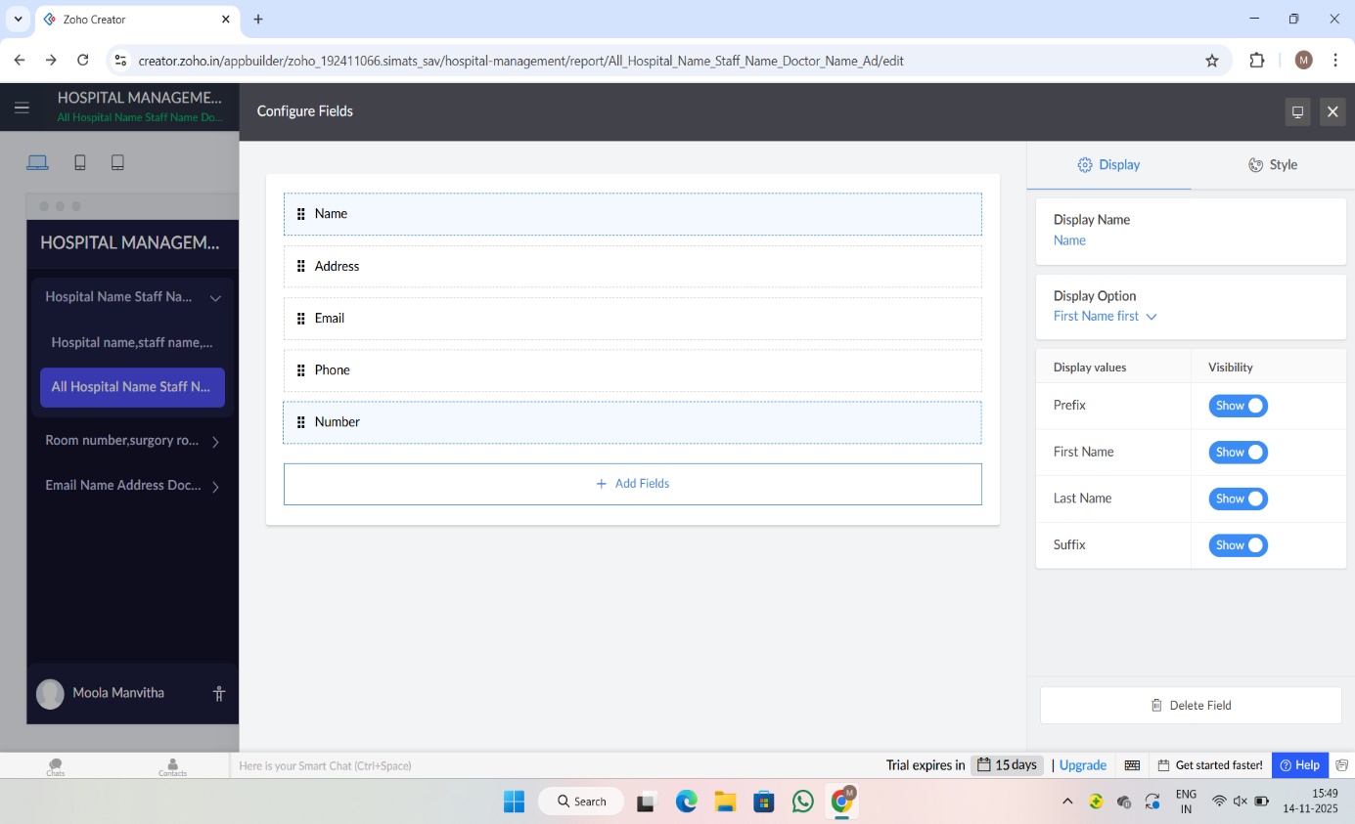
EXP NO 2: CREATE A SIMPLE CLOUD SOFTWARE APPLICATION FOR FLIGHT RESERVATION
SYSTEM USING ANY CLOUD SERVICE PROVIDER TO DEMONSTRATE SAAS.
DATE:
AIM:
To create a simple cloud software application for flight reservation system using
any cloud service provider to demonstrate saas.
PROCEDURE:
step1: Go to zoho.com.
step 2: Log into the zoho.com.
step 3: Select one application step.
step4: Enter application name as flight reservation system.
step 5: Created new application flight reservation system.
step 6: Select one form
step 7: The software has been created.
IMPLEMENTATION:
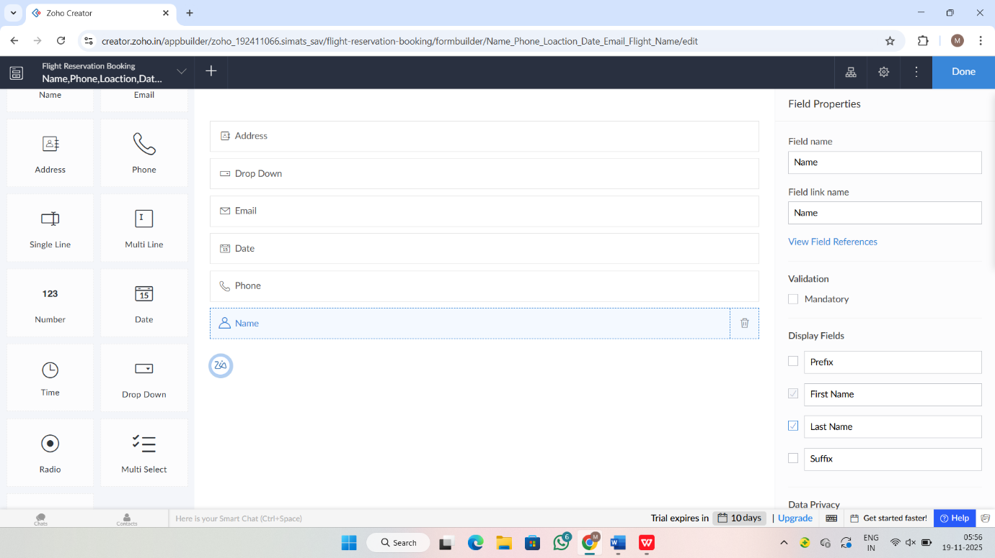
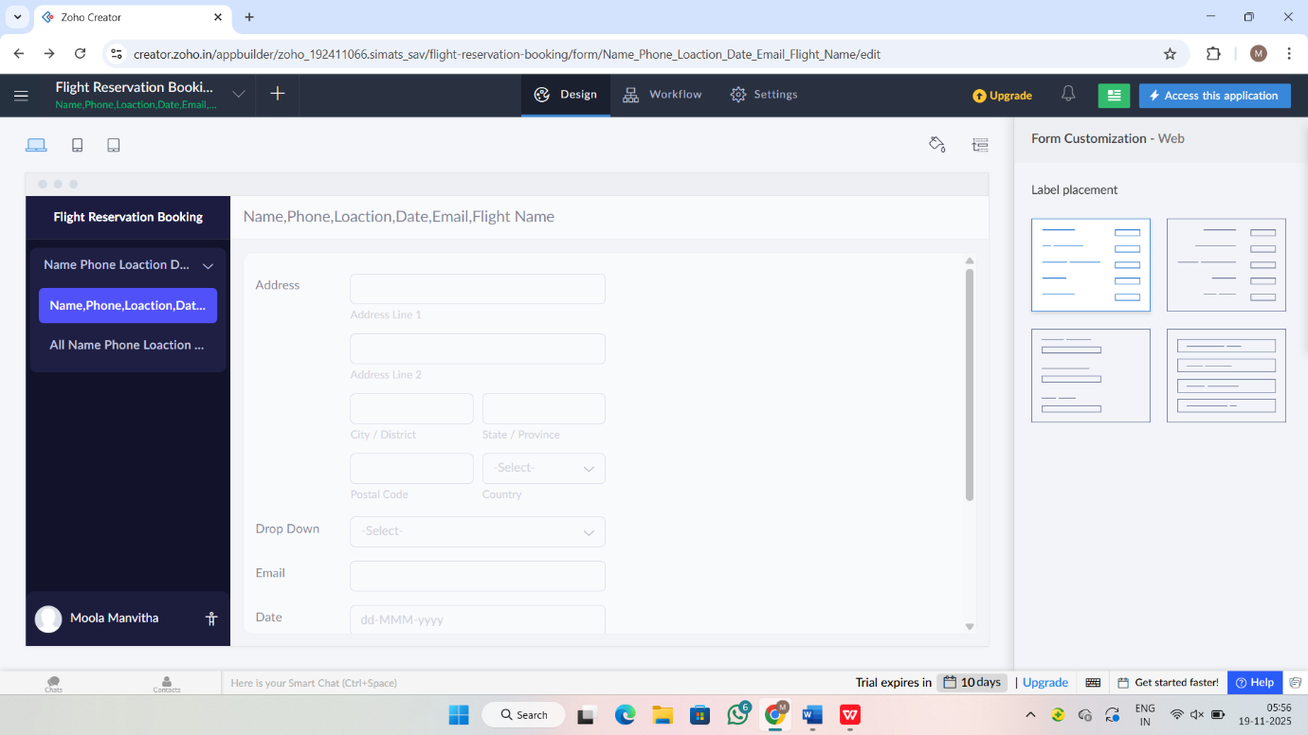

EXP NO 3: CREATE A SIMPLE CLOUD SOFTWARE APPLICATION FOR PROPERTY BUYING & RENTAL PROCESS (IN CHENNAI CITY) USING ANY CLOUD SERVICE PROVIDER TO
DEMONSTRATE SAAS.
DATE:
AIM:
To Create a simple cloud software application for Property Buying & Rental process
(In Chennai city) using any Cloud Service Provider to demonstrate SaaS.
PROCEDURE:
step1: Go to zoho.com.
step 2: Log into the zoho.com.
step 3: Select one application step.
step4: Enter application name as property buying & rental.
step 5: Created new application as property buying & rental.
step 6: Select one form
step 7: The software has been created.
IMPLEMENTATION:
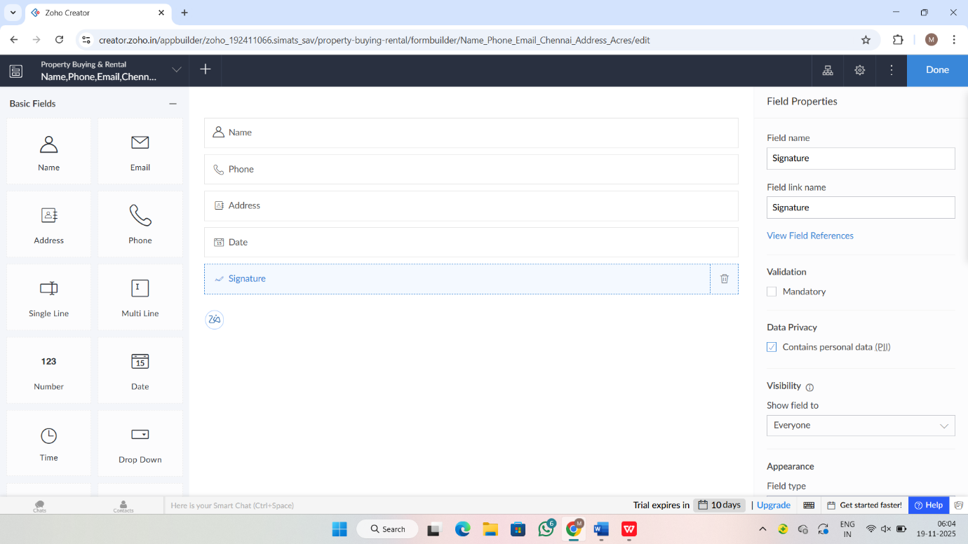
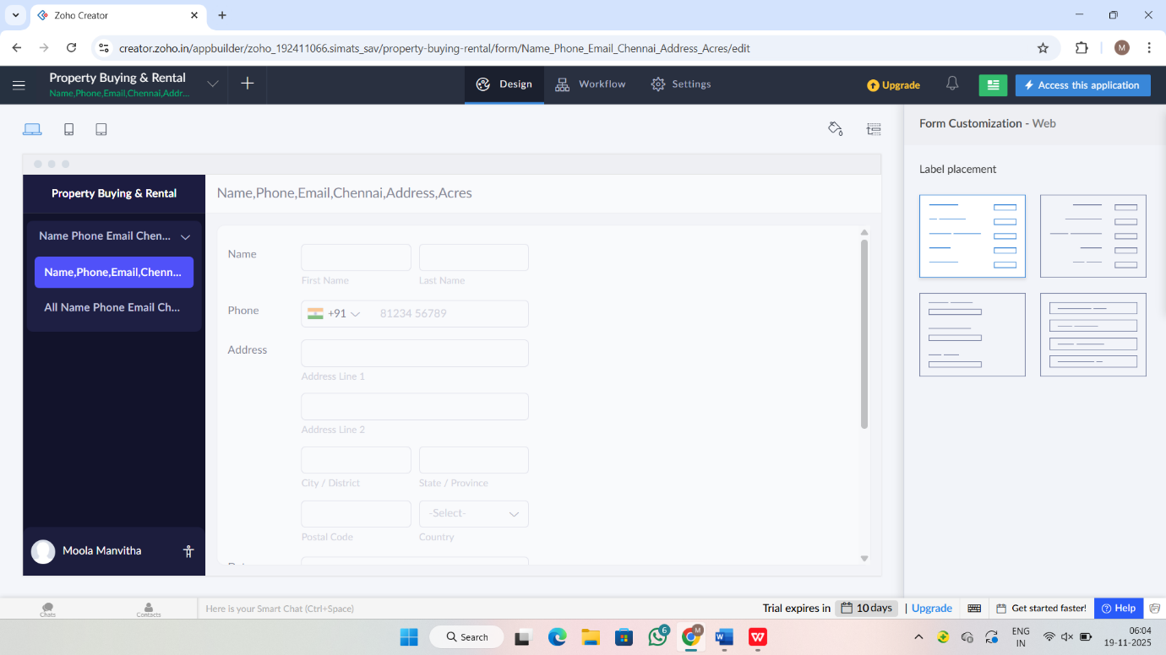
EXP NO 4: CREATE A SIMPLE CLOUD SOFTWARE APPLICATION FOR CAR
BOOKING RESERVATION SYSTEM USING ANY CLOUD SERVICE
PROVIDER TO DEMONSTRATE SAAS.
DATE:
AIM:
To Create a simple cloud software application for Car Booking Reservation System
using any Cloud Service Provider to demonstrate SaaS.
PROCEDURE:
step1: Go to zoho.com.
step 2: Log into the zoho.com.
step 3: Select one application step.
step4: Enter application name as Car Booking Reservation System.
step 5: Created new application as Car Booking Reservation System.
step 6: Select one form
step 7: The software has been created.
IMPLEMENTATION:
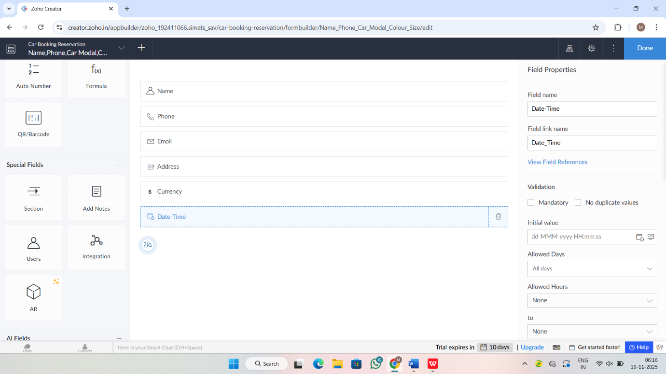

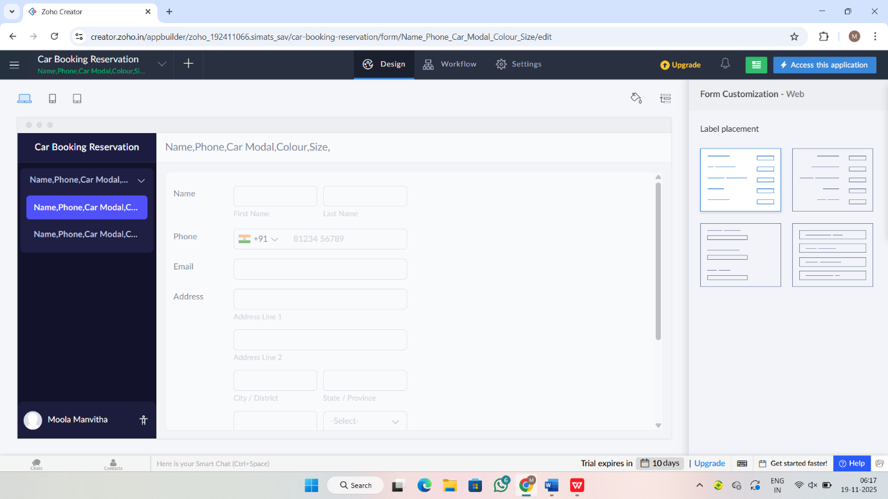

EXP NO 5: CREATE A SIMPLE CLOUD SOFTWARE APPLICATION FOR
LIBRARY BOOK RESERVATION SYSTEM FOR SIMATS LIBRARY USING
ANY CLOUD SERVICE PROVIDER TO DEMONSTRATE SAAS
DATE:
AIM:
To Create a simple cloud software application for Library book reservation system for
SIMATS library using any Cloud Service Provider to demonstrate SaaS
PROCEDURE:
step1: Go to zoho.com.
step 2: Log into the zoho.com.
step 3: Select one application step.
step4: Enter application name as library book reservation system.
step 5: Created new application as library book reservation system.
step 6: Select one form
step 7: The software has been created.
IMPLEMENTATION:
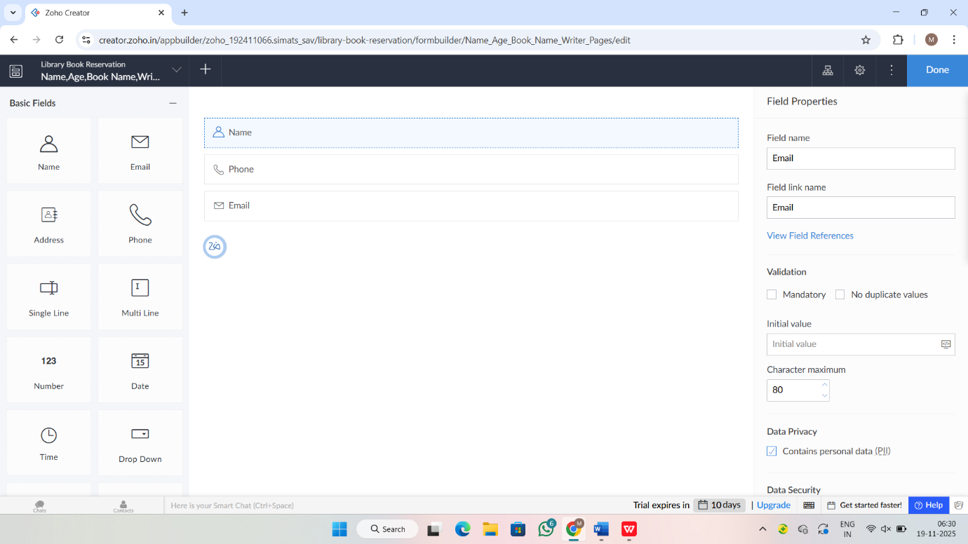
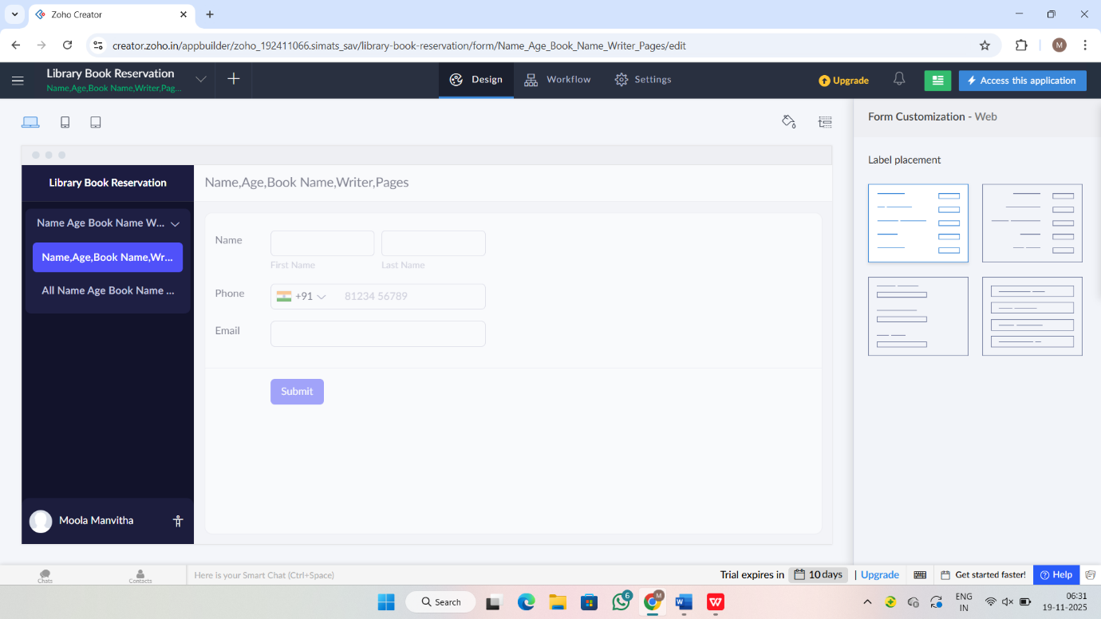

EXP NO 6: CREATE A SIMPLE CLOUD SOFTWARE APPLICATION FOR
PRODUCT SELLING USING ANY CLOUD SERVICE PROVIDER TO
DEMONSTRATE SAAS.
DATE:
AIM:
To create a simple cloud software application for product selling using any cloud
service provider to demonstrate saas.
PROCEDURE:
step1: Go to zoho.com.
step 2: Log into the zoho.com.
step 3: Select one application step.
step4: Enter application name as product selling.
step 5: Created new application as product selling.
step 6: Select one form
step 7: The software has been created.
IMPLEMENTATION:
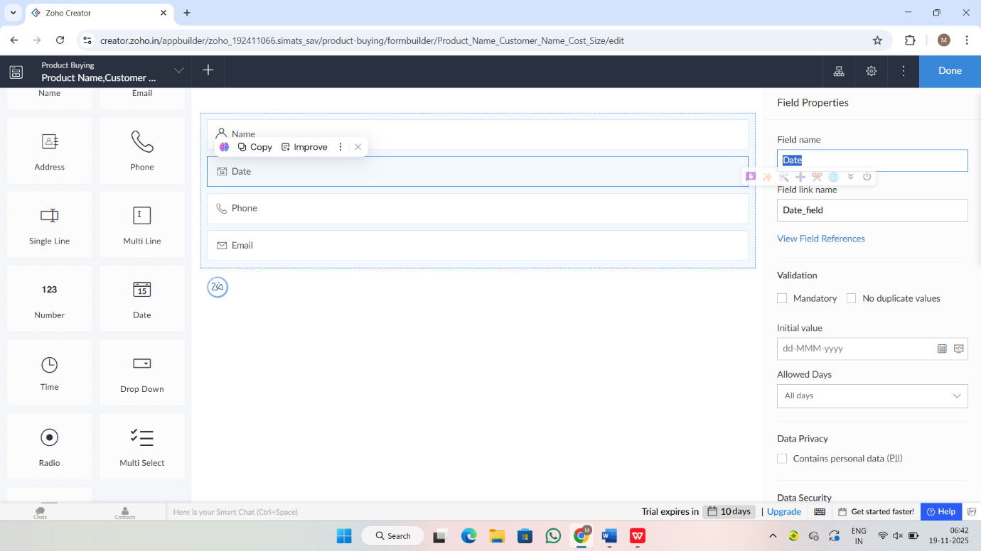
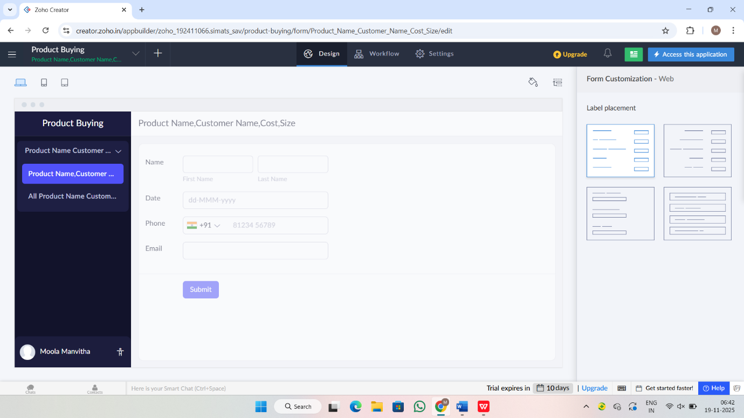
RESULT: Successfully applications are created.

